Wed Jul 19 00:07:58 2023, New Model - EER Diagram (part 1 of 1)

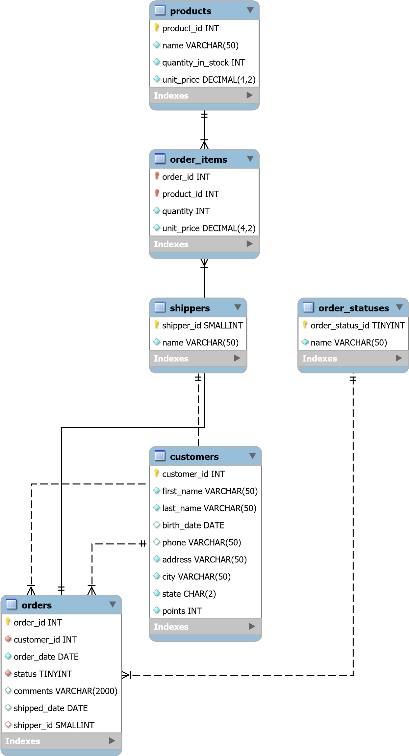

1 of 1